Springboot with AI

We can integrate all the AI available but we will use ollama AI

<https://ollama.com/download>

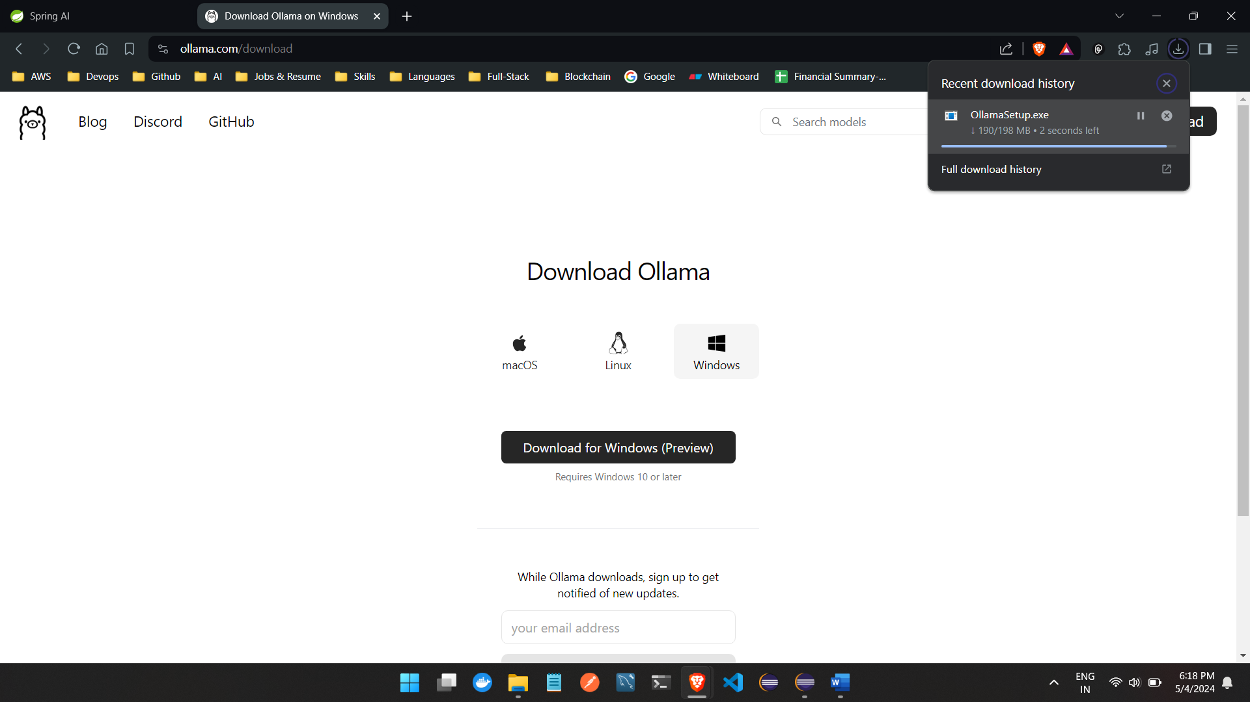

Install it :

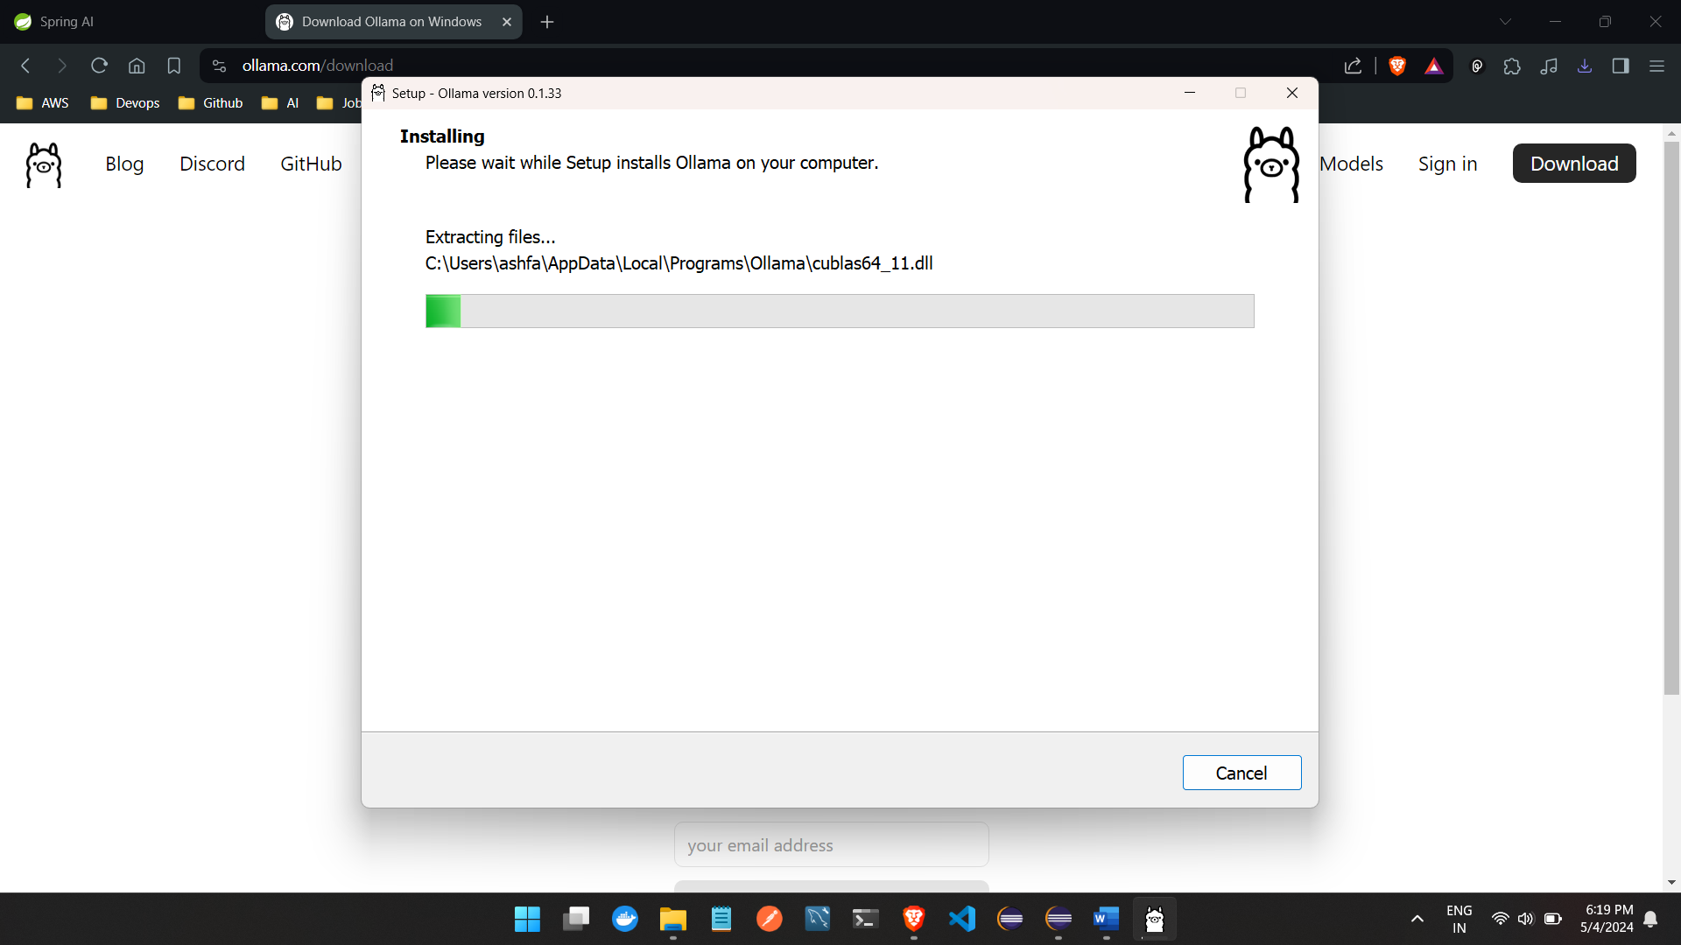

Now we have to install AI models here to view the downloaded models

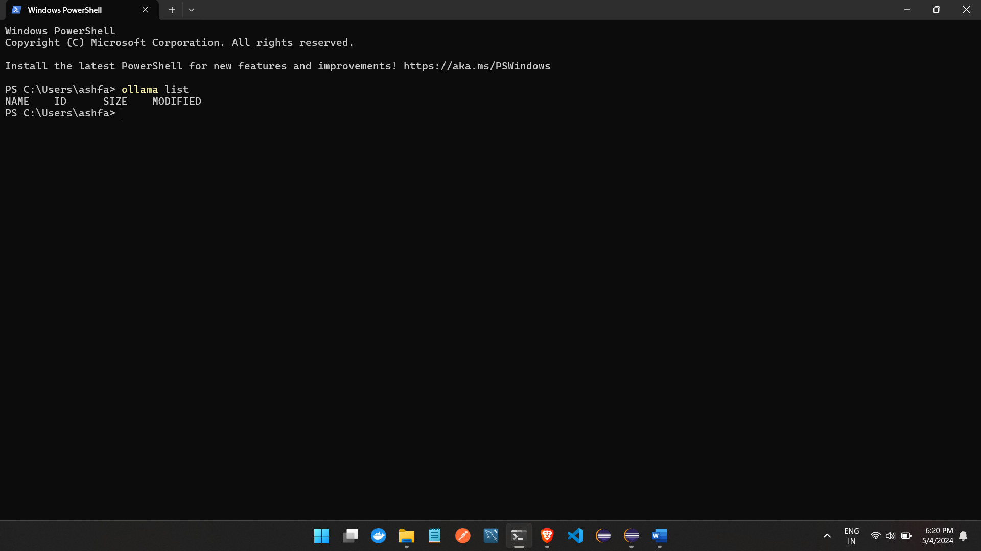

How to download AI models :

Click on models :

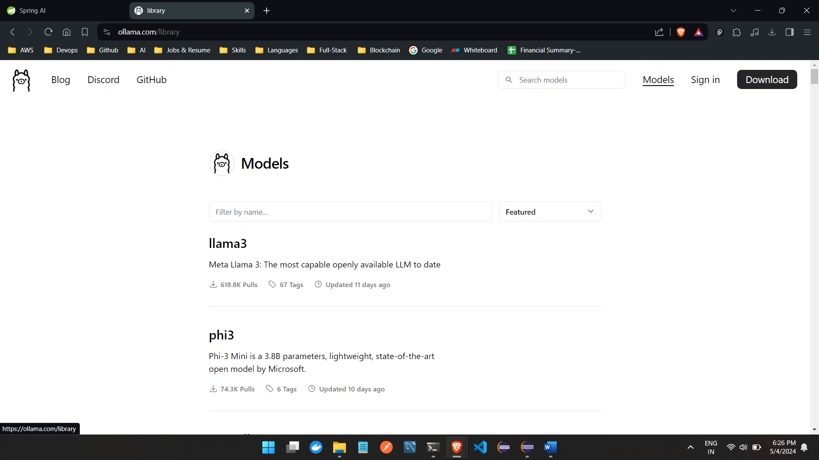

<https://ollama.com/library/mistral> we will download mistral AI and run localy

the command to download the mistral AI ollama run mistral in terminal and 4Gb file size

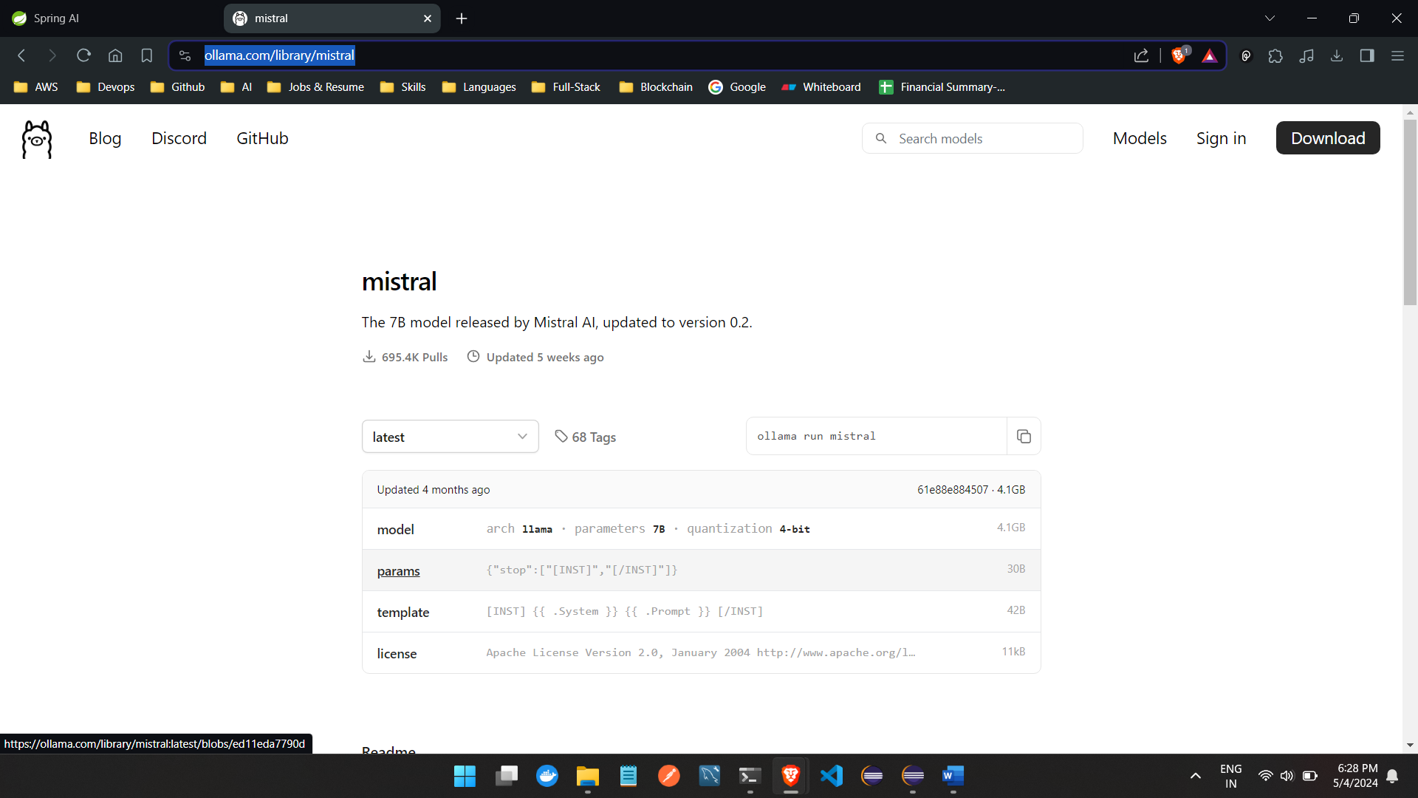

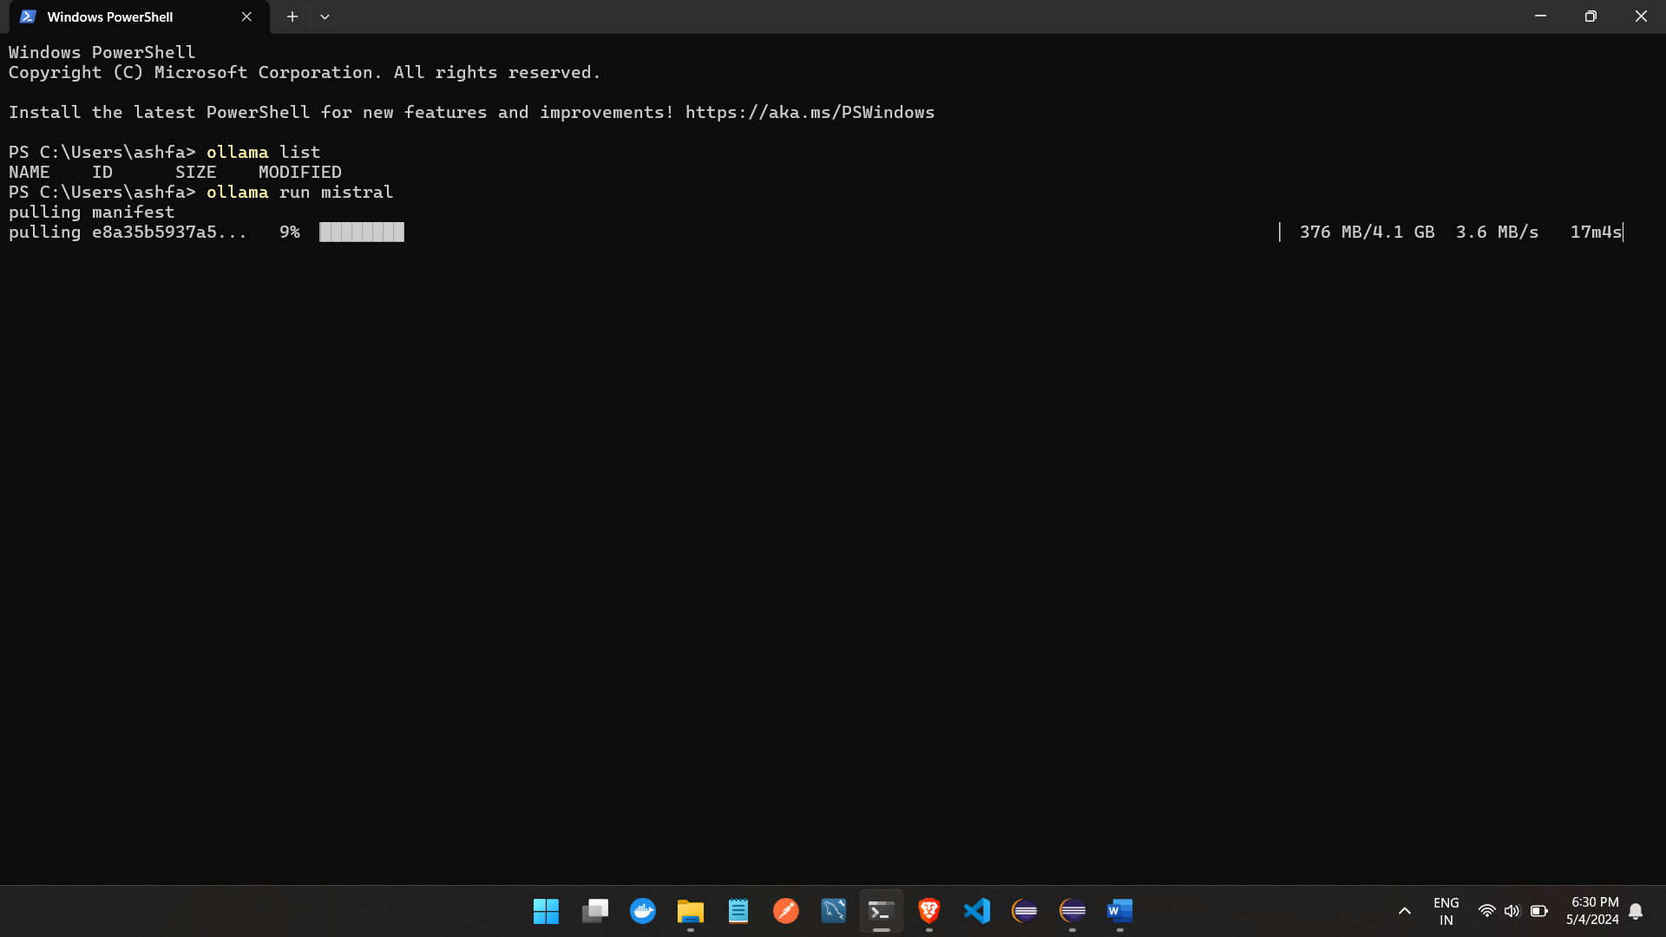

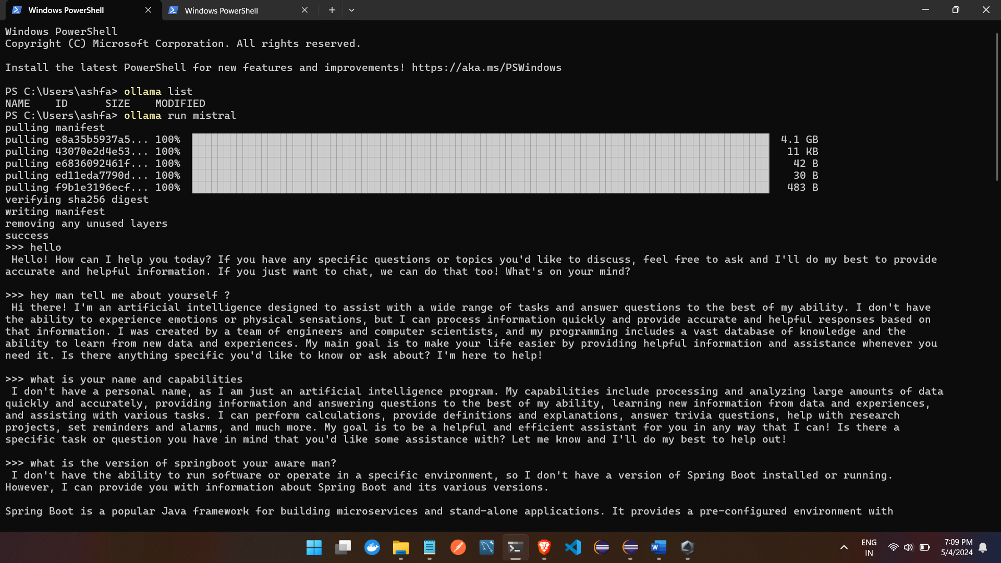 once downloaded to run this is the command from terminal : **ollama run mistral**

**This will run offline but wont have access to your files**

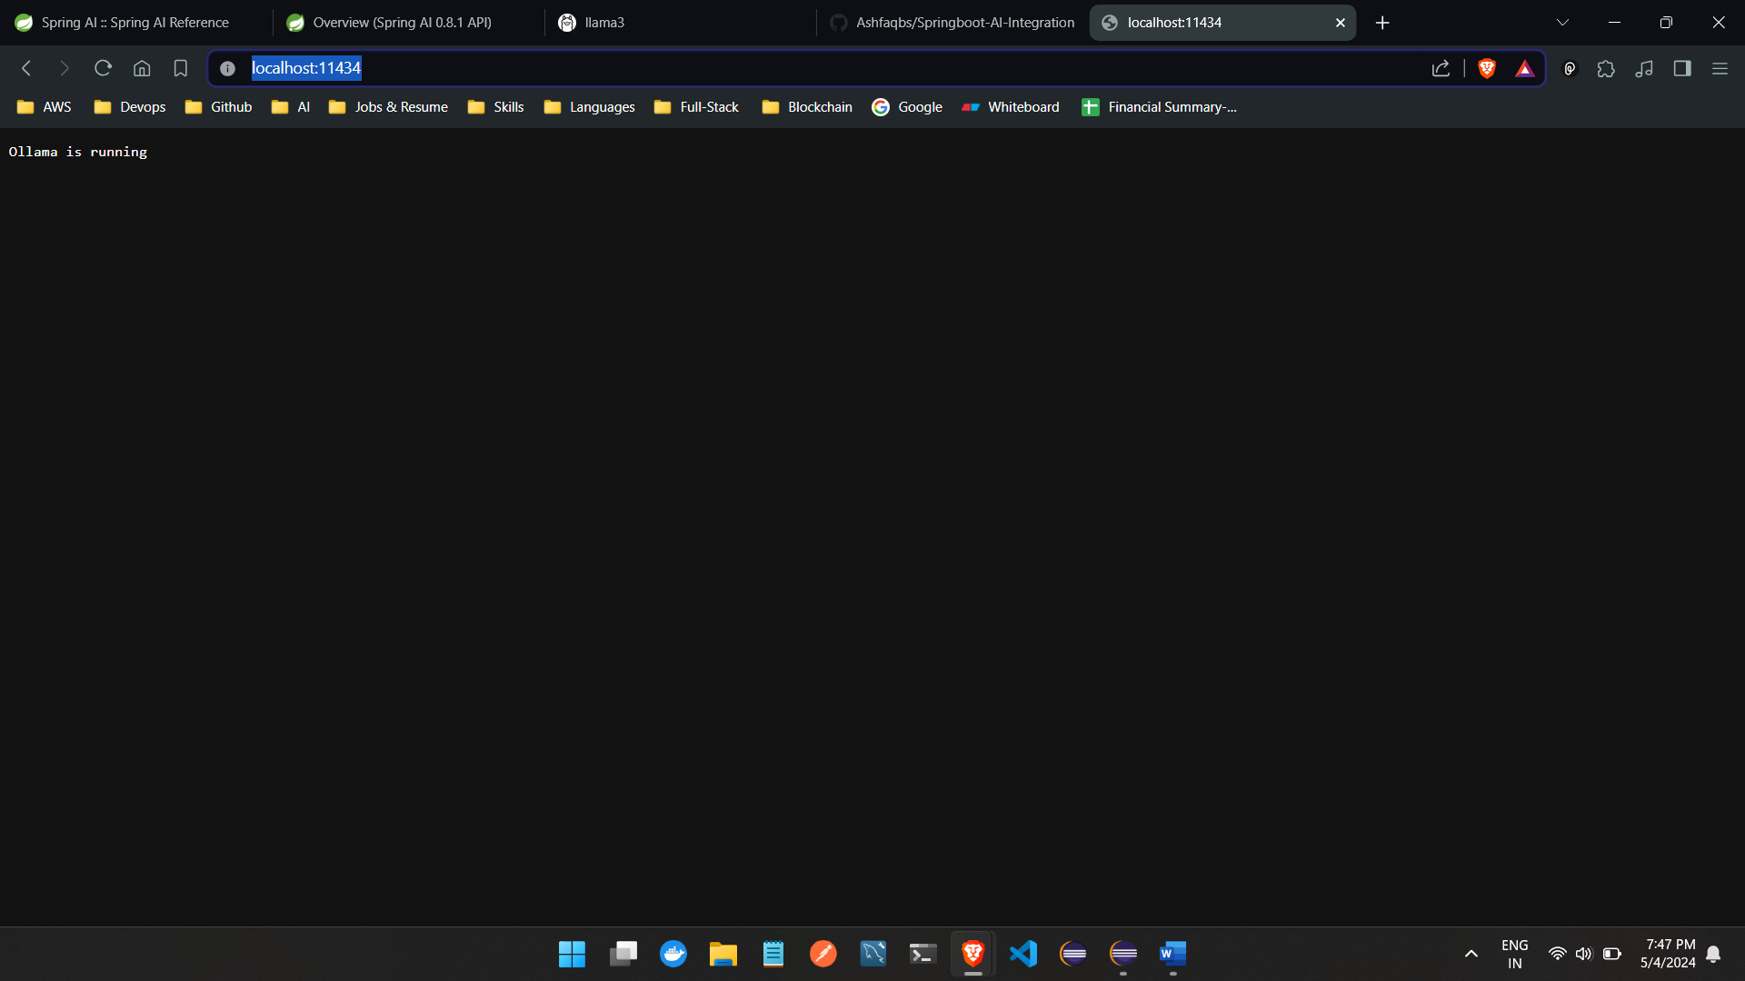

[**http://localhost:11434/**](http://localhost:11434/)

**lets create a springboot project to test**

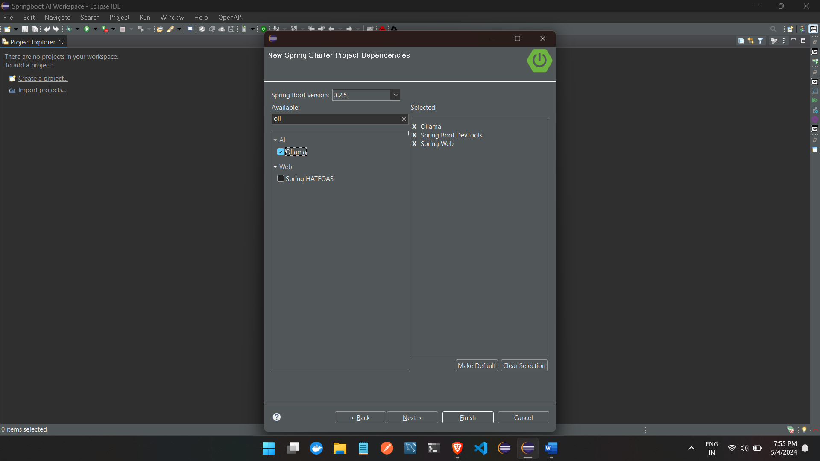**this is the dependency as we are using ollama and from it mistral we have added ollama dependency**

**Add props in app.props**

spring.application.name=Springboot3-AI-Ollama-MistralOffline-Integration

#https://docs.spring.io/spring-ai/reference/api/clients/ollama-chat.html

spring.ai.ollama.base-url=http://localhost:11434

spring.ai.ollama.chat.options.model=mistral

spring.ai.ollama.chat.options.temperature=0.7

#In the context of AI models, particularly those used for generating text or responses, the "temperature" parameter controls the randomness of the output. A higher temperature value (e.g., 0.7) makes the output more random and creative, while a lower value (e.g., 0.2) makes it more deterministic and focused on the most likely predictions.

#This parameter is crucial for balancing between creativity and coherence in generated content.

**And use the classes and run the project**